Head Up Display (HUD)

Goals

- Simple, effective, animated presentation of the information the user needs

Features

- The information the user needs on the HUD is:
  - Map for navigation, including location of collectibles and AI opponents
  - Counter-measure availability and use indicator
  - Damage meter
  - Speedometer (question: digital or analog?)
  - Indication of collectible requirement/status for multiple collectibles, e.g., if you have to deliver or destroy N objects
  - Mission objective (text? Or just character dialog?)
  - The Heads Up Display (HUD) will incorporate a gauge that tells the user how hard they are pressing the analog PS2 gas button. The purpose of this is two-fold:
- Let the user know when they are pressing "full gas"
- Lets us incorporate analog control into simple vehicle maneuvers (e.g., stomp on gas to peel out or do a donut, or apply it more gradually to do a smooth start)

- The map, damage meter, and counter measures can all be shown in one simple HUD object as in Smuggler’s Run 2:
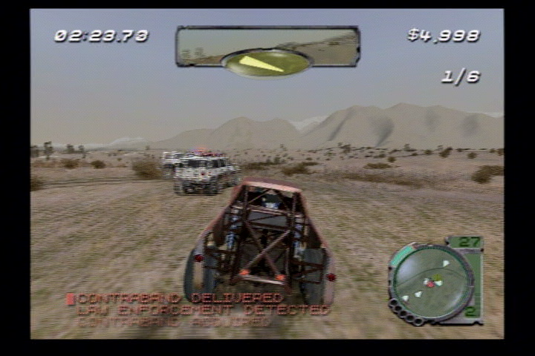
    - Simple animation (flashing) on counter-measure light when it’s used (or recharged)
- The collectible status will glow or pulsate, with a sound effect, when it is updated
- A timer – this is one of the most prominent HUD elements, since time will be a factor in most missions.
  - Simplest solution is a simple digital counter
  - Needs animation (e.g., blinking red) and sound, both of which increase in frequency, as it nears zero – same system and logic as Road Rage should work fine
  - If there’s a way to make it prominent enough, it can be part of the HUD map “object” – but it may be hard to read? Does it need to be separate “floating” text? Same issue applies to collectible status.
- We need presentation for mission success/failure events and one aspect of this requires HUD art and animation – the “mission status” reward that the user earns:
  - There will be four levels of success – like the gold/silver/bronze in other games
  - The 4th rating is “skipped”; if a user fails a mission ten times in a row we will ask them if they want to skip it
  - There will be character animation and presentation for the mission-complete state; can we add an object to this presentation to indicate status? e.g., plain donut, chocolate donut, donut with sprinkles?
  - We need to think of the reward for completing the game at silver or bronze
    - Maybe it’s an additional gameplay mission in the Halloween level

Tools

- The simpler the better. All we should need to tune is animation around collectible status update, timer, and mission success/failure text

